Install Elastic Search

While navigating to localhost:9200, shows elastic search is installed

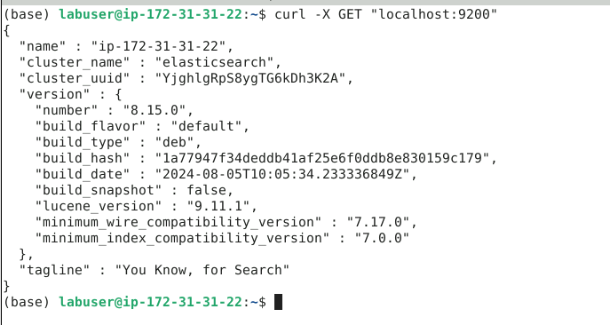

On executing the command, /usr/share/logstash/bin/logstash -f /etc/logstash/logstash.conf

Logstash getting started and entering message Hello First message, getting the message

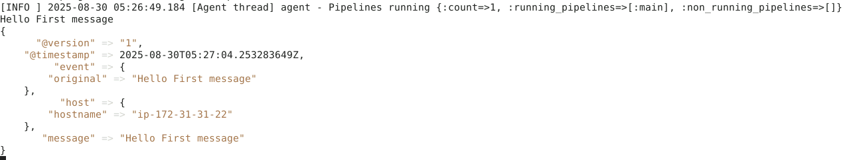

On executing curl -X GET "localhost:9200/test_index/_search?pretty", gives output

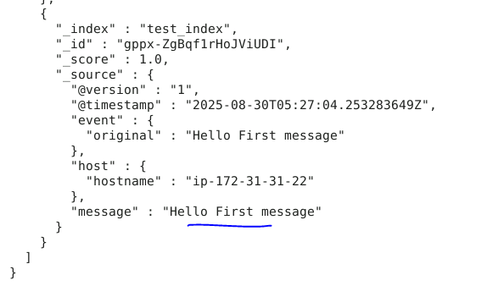

On navigating to **http://localhost:5601**



On Index management, configured test_index

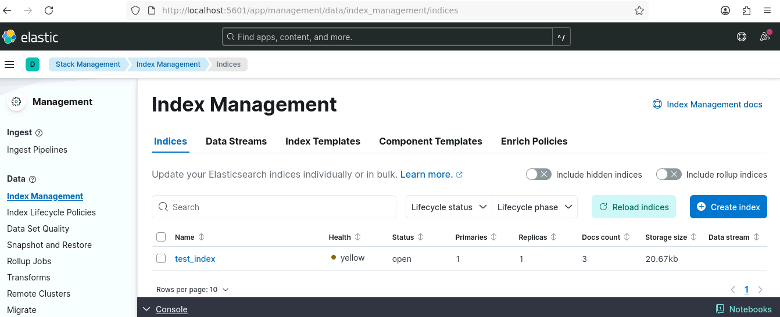

On Visualize Library, create select logstash, dragging @timestamp field shows

